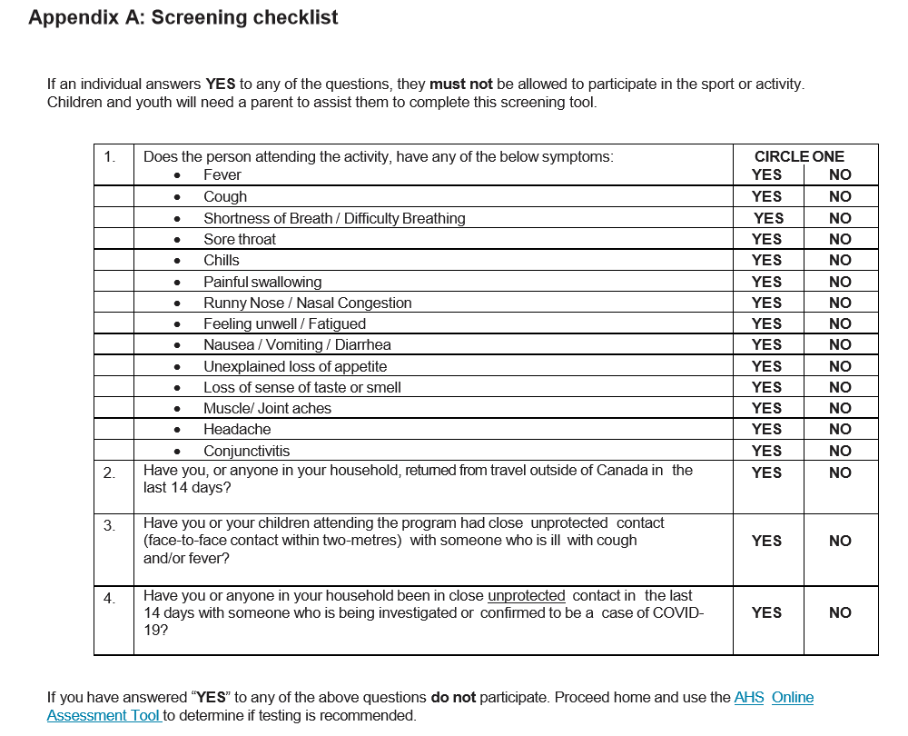

Name(s): ______________________________________

______________________________________

Phone Number: ______________________________

Date: _________________ Time: ________________